Moore Momentum
Build Progress & Documentation Traceability
Prepared for Will Moore · Plain-Flutter rebuild · Last updated 2026-06-30

This document maps every feature built so far back to your original specification documents, quotes the exact passage each feature was built from, and shows a screenshot of the working app. The goal is a single place where you can see what was built, why (which of your docs drove it), and that it works.

1. Your source documents
All features are traced to the four specification files you provided in
Doc | Original document (.docx) | Used for
A | PHASE 1 AND 2 SEQUENCE (… FOR CODERS) (2).docx | The master spec — onboarding (HHS / MBS), the Daily Ritual, Core Balance, Command Center.
B | Gamification Mechanics Specs Reference (Pre-PRD).docx | Momentum Points, streaks, badges, Space Credits economy.
C | Product Design Rationale.docx | The why behind the AI flagging + Core Balance enforcement.
D | Space Cantina – Social Component Of The MM System.docx | The social hub (Cantina) gating + rollout.
How to find a quote in your docs: Word .docx files don't have stable page numbers, so each citation gives the section heading + the verbatim quoted text. Open the document, press Ctrl-F, and paste the quote to jump straight to it. For internal traceability we also note the line number in the plain-text extraction stored in design/ref/_extracted/.

2. Progress at a glance
Milestone | Feature | Status
M0 Foundation | #1 Persist Phase 1 state to Firestore | Done
 | #2 Real phase gating (no debug toggle) | Done
M1 Onboarding | #3 HHS Stage 1 driven by the AI | Done
 | #4 MBS Stage 2 real + Cantina unlock | Done
M2 Daily ritual | #5 Daily Ritual Step 0 (Mantra & Gratitude) | Done
 | #6 Real numbers in Progress Summary | Done
 | #7 Persist Mission Control flags + AI auto-flag | Done
 | #8 Core Balance 5-day alert | Done
M3 Economy | #9 Momentum Points engine | Done
 | #10 Streak system | Done
 | #11 Trophy Room from real formation | Done
M4 | #12 Profile screen real data | Done
The canonical living backlog is COMPLETION_PLAN.md in the project root.
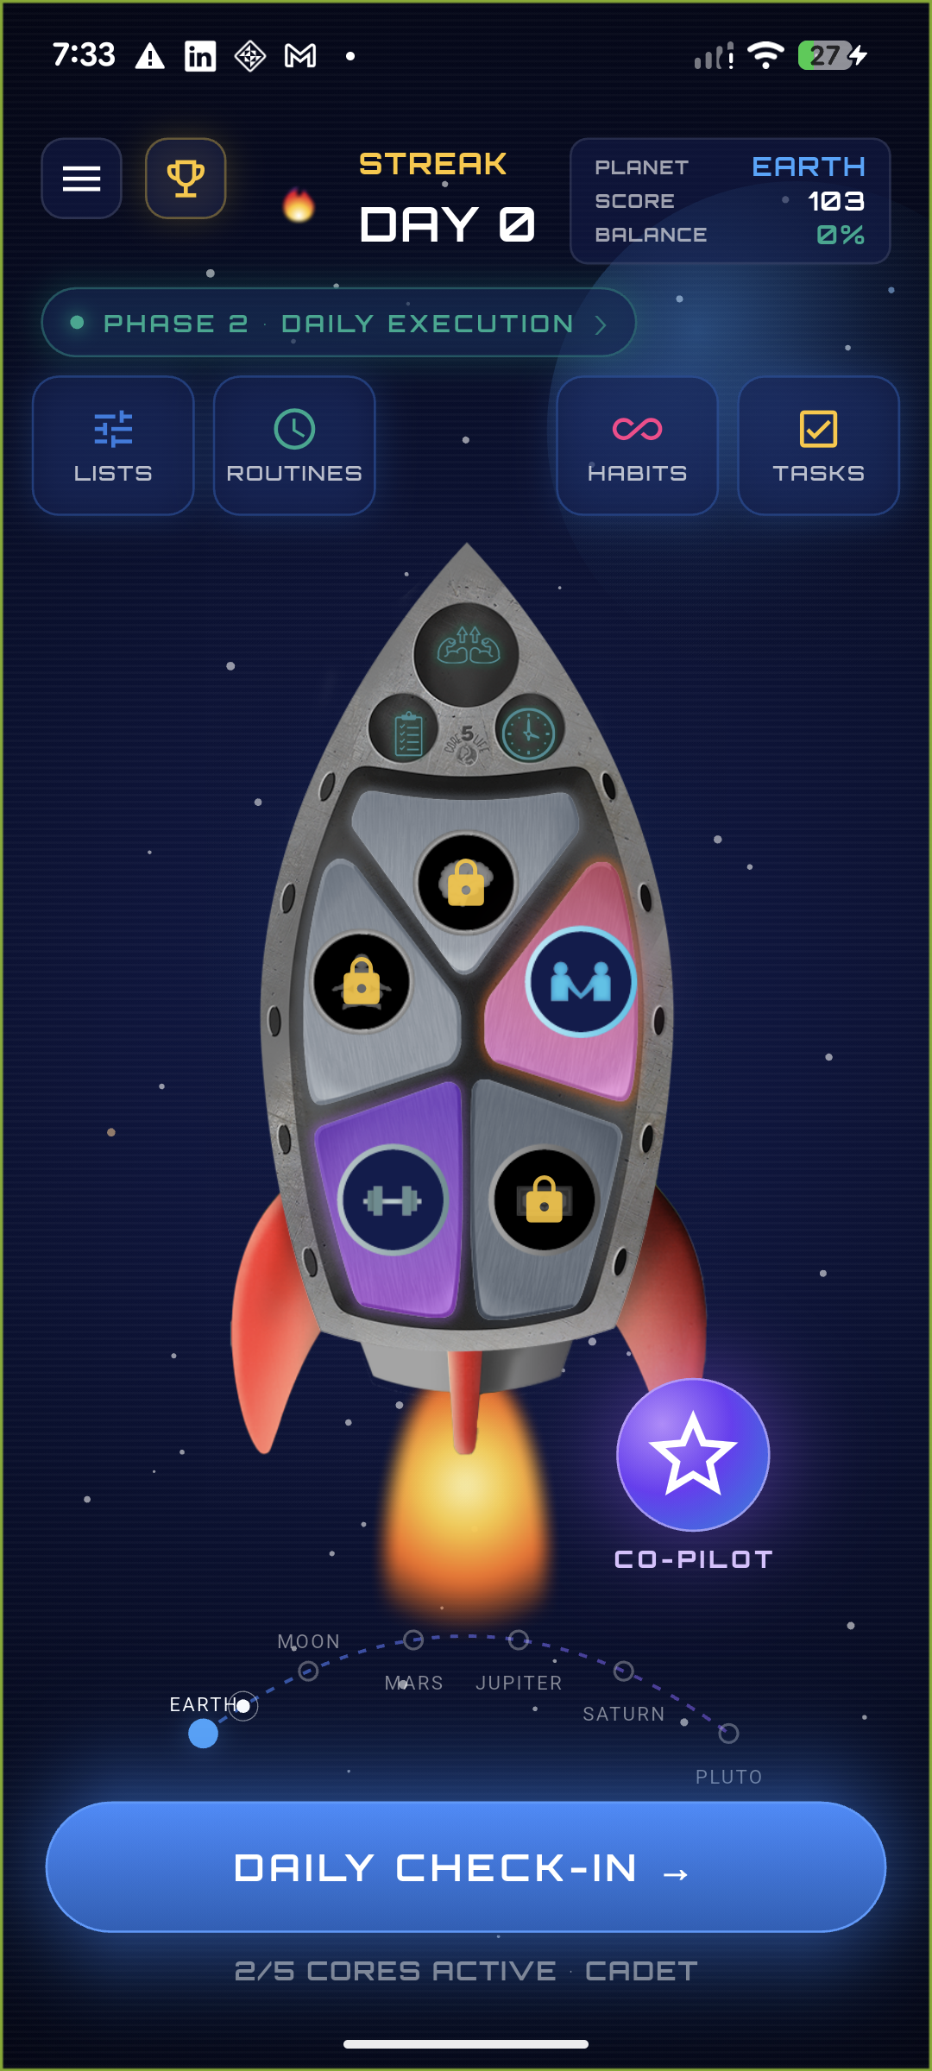
The main cockpit (Screen 3.1). The rocket's 5 panels are the 5 Core Areas of Life; the phase pill shows whether the player is in Phase 1 (build) or Phase 2 (daily execution).

M0 — Foundation

#1 Persist Phase 1 state to Firestore
What this is: The player's onboarding progress (Stage 1 / Stage 2 completion, pyramid progress) and current phase are saved to the cloud, so they survive an app restart and sync across devices.
Source — Document A — the Phase 1 → Phase 2 progression & the returning-player "Re-Entry Bridge" ("Path A: Rebuild This Habit → Phase 1, Stage 1 (HHS)") all depend on persisted progress.
These returning-player flows are only possible if Phase 1 progress is persisted across sessions.
Built: New flutterSavePhase1State cloud function + phase1 fields on flutterGetUserProfile (the phase — build vs daily — is derived server-side from stage1Completed && stage2Completed). Client: ProfileService.savePhase1State, written back on every Phase-1 change and on each check-in.

#2 Real phase gating (cores grayed until first habit)
What this is: Removed the temporary debug toggle. The dashboard shows the player's real phase, score, streak and which Cores are active — a Core lights up only once it has a Golden Habit.
Source — Document A, section "Core Unlocking — Progressive System" (extracted ref line 2140):
“Cores appear grayed out until the player creates their first habit in that Core. Unlocks progressively as the player adds habits across additional Cores — encouraging holistic exploration across all 5 areas rather than over-indexing on one.”
Built: flutterGetUserProfile derives activeCores live from the golden_habits sub-collection; the rocket renders a Core in colour only when active, grayed (with a gold lock) otherwise.

M1 — Onboarding

#3 HHS Stage 1 driven by the AI
What this is: The first onboarding stage (Habits Hierarchy System) is now an embedded AI conversation with “Nova” — Pain Point → Core → Universal Principle → Keystone → Golden Habit, with a celebration + points at each checkpoint.
Source — Document B, section "Phase 1, Stage 1" (extracted ref line 225):
“Momentum Points are introduced and earned at each Habits Hierarchy checkpoint: 10 pts (Truth Seeker) → 15 pts (Principle Decoder) → 20 pts (Keystone Forger) → 25 pts (Core Dimension Explorer) → 40 pts (Golden Habit Architect).”
Built: The live Nova chat (hhs_chat_view.dart) drives your existing Voiceflow onboarding agent; a read-only flutterSyncOnboarding endpoint reports progress so the pyramid advances and reward overlays fire from the points the agent awards. The forged Golden Habit is persisted and lights up its Core.

#4 MBS Stage 2 real + Space Cantina unlock
What this is: The second onboarding stage (the 3 Momentum Boosting Methods — Make It Obvious / Easy / Rewarding + an IF-THEN obstacle plan) is real: picks are saved onto the Golden Habit, badges + points are awarded, and completing it unlocks the Space Cantina.
Source — Document B, section "Phase 1, Stage 2" (extracted ref line 226):
“Momentum Points continue: 10 pts (Friction Hunter) → 15 pts (Method Master) → 25 pts (Implementation Wizard). Space Cantina unlock at Stage 2 completion includes a 25 Space Credit welcome bonus.”
Built: New flutterSaveMomentumMethods endpoint merges the 3 methods + IF-THEN onto the active Golden Habit and awards the three badges once. The Cantina screen is gated behind persisted stage2Completed (a “locked” view deep-links into Stage 2 until done).
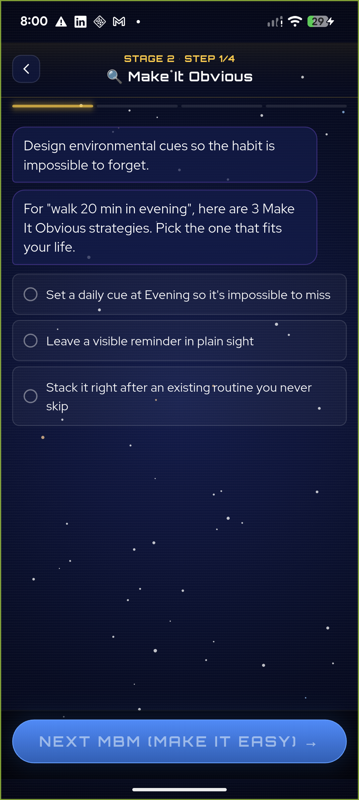
Stage 2 (MBS): the player picks one Make-It-Obvious strategy, personalised from their real Golden Habit (“walk 20 min in evening”). Completing all three methods + the IF-THEN plan unlocks the Cantina.

M2 — The Daily Ritual

#5 Daily Ritual Step 0 — Mantra & Grateful List
What this is: An optional, skippable screen shown before the daily scoring, to set the player's emotional state. It shows their Mantra and Grateful List and links into the Command Center.
Source — Document A, section "STEP 0 (OPTIONAL): MANTRA & GRATEFUL LIST" (extracted ref lines 2176-2183):
“Haven't done your Mantra or Grateful List yet today? Want to set your emotional state before reviewing yesterday's performance? [View Your Mantra] [View Your Grateful List] [Skip - I'll Do This Later] [Continue to Scoring →] … those lists open from Command Center, then return here.”
Built: New daily_ritual_step0.dart, inserted ahead of the check-in. It reads the player's Momentum Lists, matches the Mantra & Grateful buckets, and the “View” buttons open the Command Center Lists screen and return. Per-day completion is remembered so it appears at most once a day.
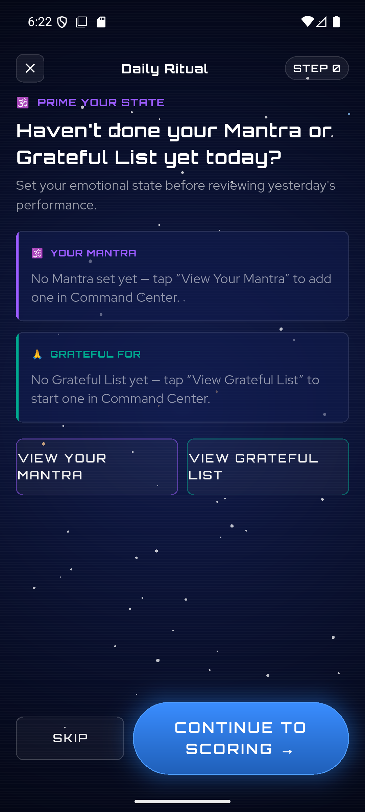 | 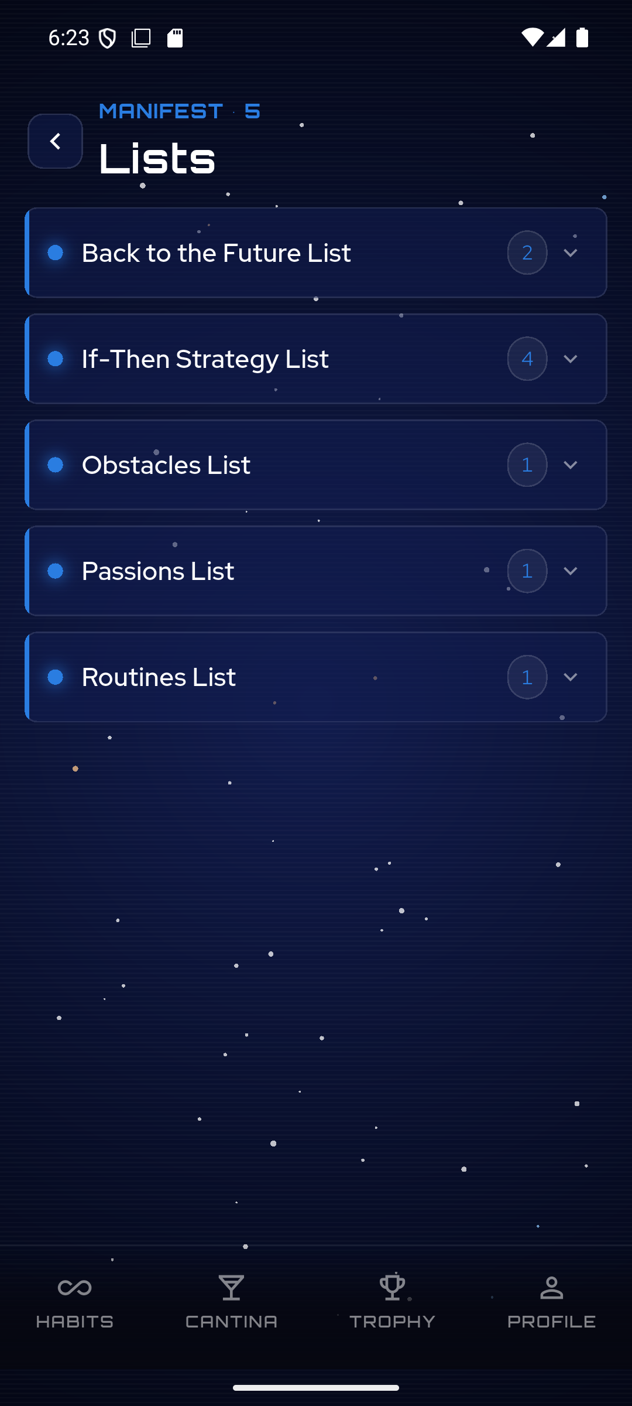
Left: the Step 0 “prime your state” screen. Right: the Command Center / Momentum Lists it links into.

#6 Real numbers in the Progress Summary
What this is: The post-check-in “Mission Recap” no longer shows fake numbers. Total Momentum and streak are real; the 5-Core Balance Meter is the real rolling 7-day average of check-in scores. Anything depending on not-yet-built systems is clearly marked “coming soon” — no fabricated figures.
Source — Document A, "Step 2 — Progress Summary" / "5 Core Balance Meter" (extracted ref lines 1997, 2033); and Document B, "Core Balance Meter — Visual showing balance across all 5 cores with 7-day rolling average."
“View Momentum Points earned, streak status, Space Credits balance, planet journey progress, 5 Core Balance Meter, and ship upgrade status.”
Built: summary_page.dart rewritten — Total Momentum + streak from the real profile; the Balance Meter computed from the last 7 days of real check-ins. Economy stats (per-check-in points, Space Credits, Daily Challenge, Mystery Box) shown as clearly-labelled placeholders pending their engines.
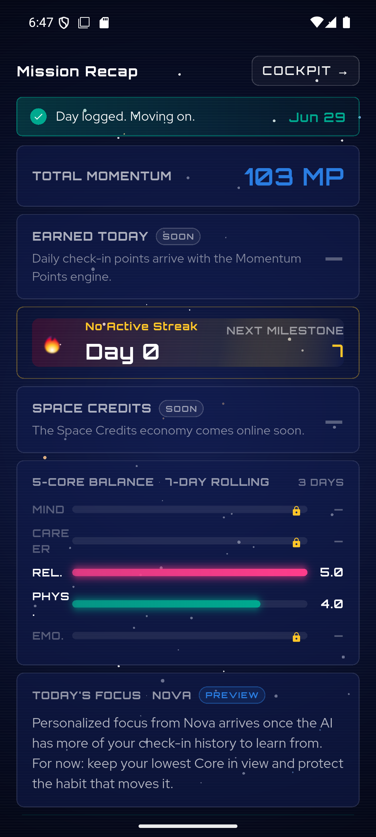
The Mission Recap: real Total Momentum, real 5-Core Balance Meter (Rel 5.0 / Phys 4.0 from actual scores), and honestly-marked “SOON/PREVIEW/COMING SOON” placeholders.

#7 Persist Mission Control flags + AI auto-flag
What this is: When a habit is struggling, the player can flag it for refinement, and the AI auto-flags a Core that's been low for several check-ins. Flags are saved to the Golden Habit, and “Go Deeper” carries the flagged habit back into Phase 1 to rebuild it.
Source — Document C (Product Design Rationale), combined AI + player flagging (extracted ref line 196):
“AI auto-flags when it detects: 3+ consecutive low scores on a habit; recurring negative themes in Captain's Log entries referencing that habit; or a Core average trending below 3 for 3+ days. Players can manually flag any habit via a [Flag This Habit] button at any time. Both AI-flagged and player-flagged habits display a warning indicator in all views. Once flagged, the player selects a resolution path.”
Built: The check-in's Mission Control intervention flags the Core's real Golden Habit via flutterFlagGoldenHabit; the “Pattern Detected” chart uses real recent scores; the auto-flag fires on 3+ consecutive check-ins ≤ 3.0; “Go Deeper → Better MBM Strategies” pre-loads the flagged habit into Stage 2. (Also fixed a rendering bug leaving the check-in habit cards blank.)
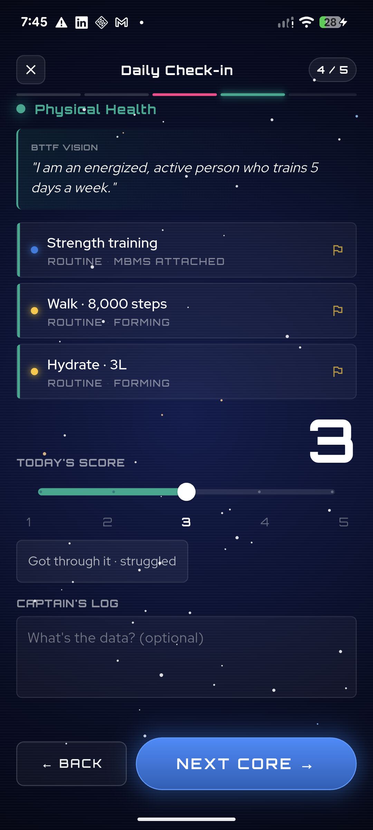
The daily check-in scoring a Core, with its habit rows and per-habit flag icons — these cards were rendering blank before this fix; tapping a flag opens Mission Control.
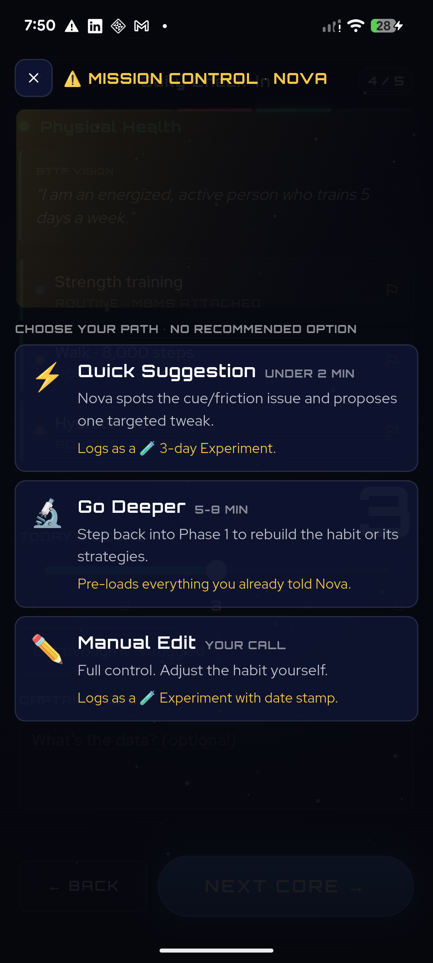 | 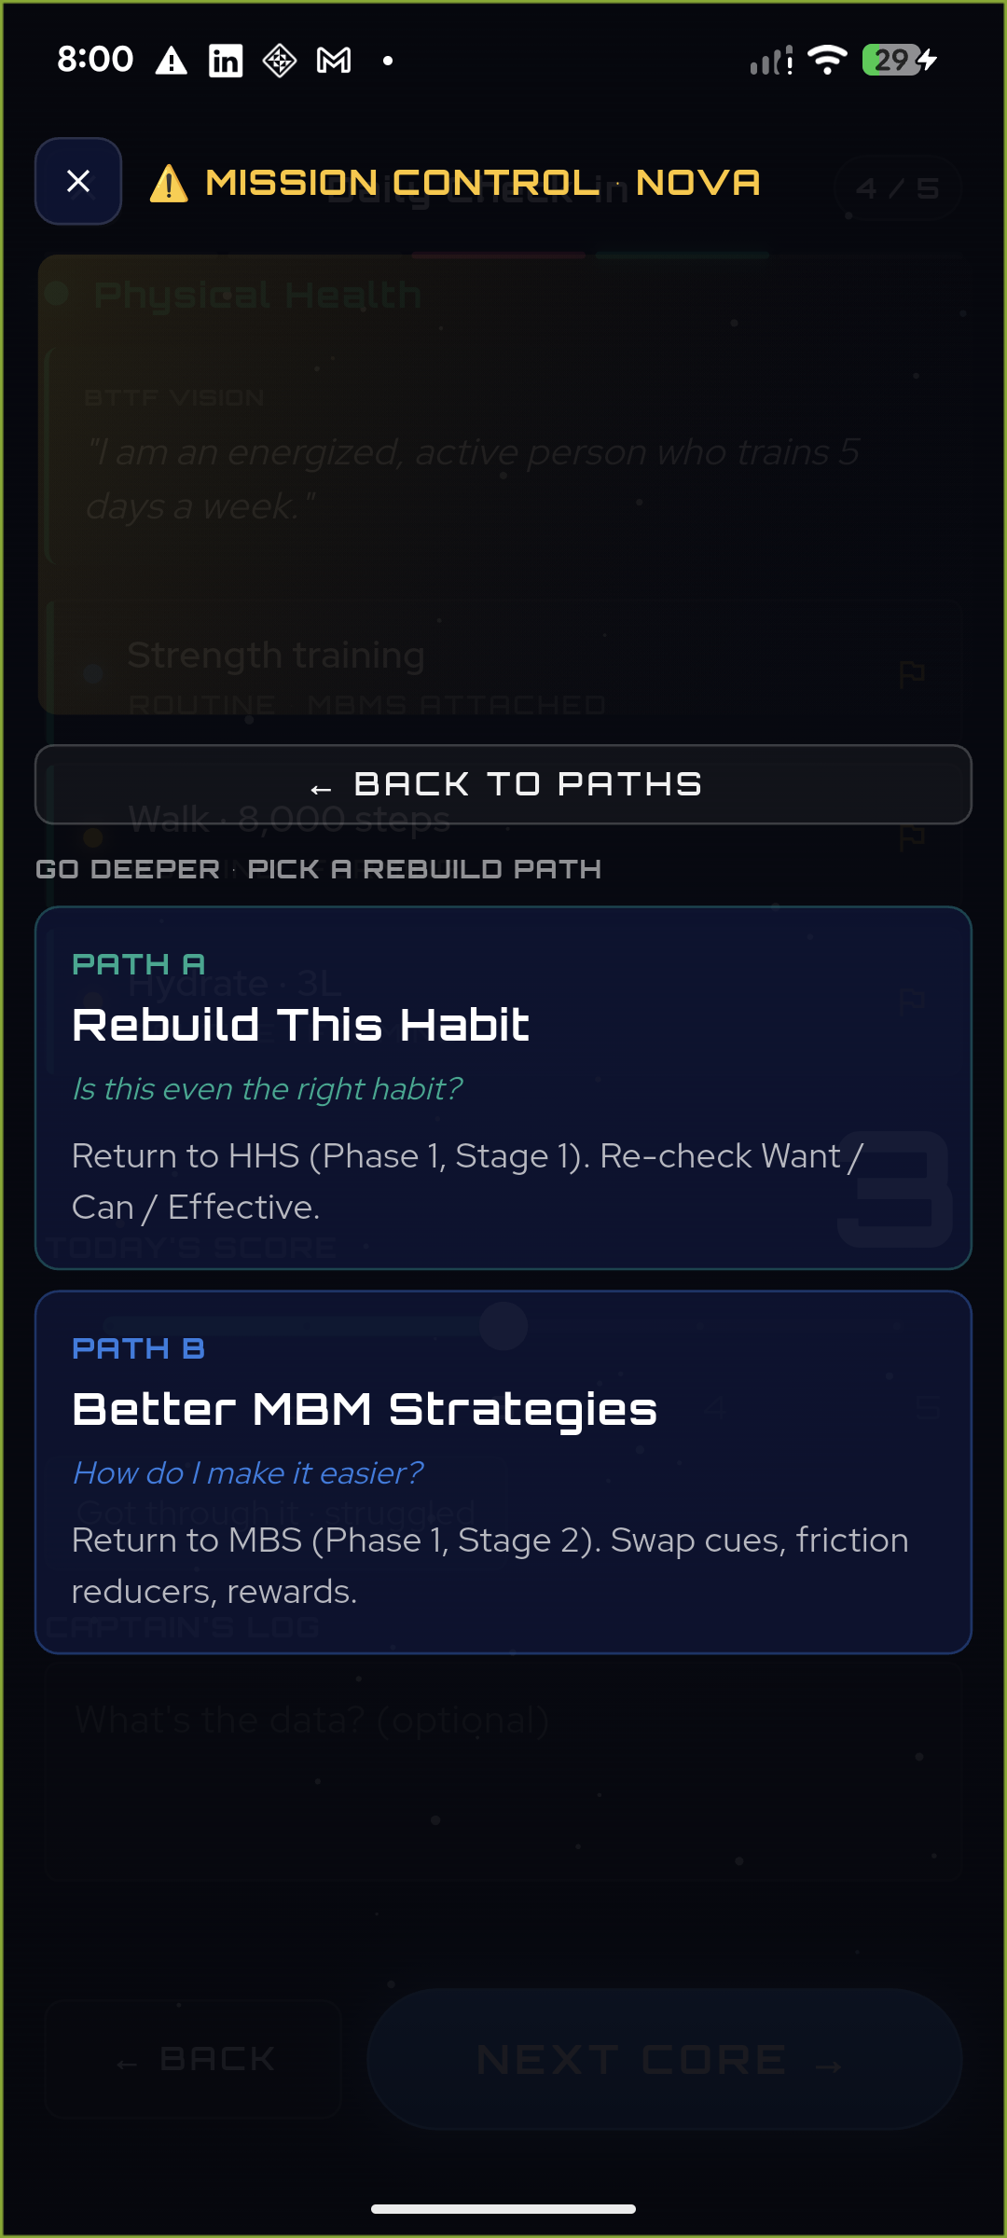
Left: the three resolution paths (no “recommended” option, by design). Right: “Go Deeper” → Path A (rebuild the habit) / Path B (better strategies), which return the player into Phase 1.

#8 Core Balance 5-day alert
What this is: If any Core is scored below 3.0 for 5+ days in a row, a red warning badge appears on that Core (on the dashboard and in the check-in). Tapping it opens a supportive “iCore Alert”.
Source — Document A, section "When a Core Is Out of Balance" (extracted ref lines 2132-2138):
“Red alert badge appears on the Core section (⚠️). Tapping opens an 'iCore Alert' message: 'This core is unbalanced. You should focus your work to improve it.' Shows recent low scores (below 3.0 for 5+ days). Suggests reviewing habits in that Core. Links to detailed habit views. [Done] button to acknowledge.”
Built: Detection (isCoreOutOfBalance = 5+ consecutive days < 3.0) from real check-ins; a red badge on the dashboard rocket Core and an “AT RISK” chip in the check-in; both open the new CoreAlertSheet carrying the exact spec copy, the recent low scores, review links, and a [Done] button.
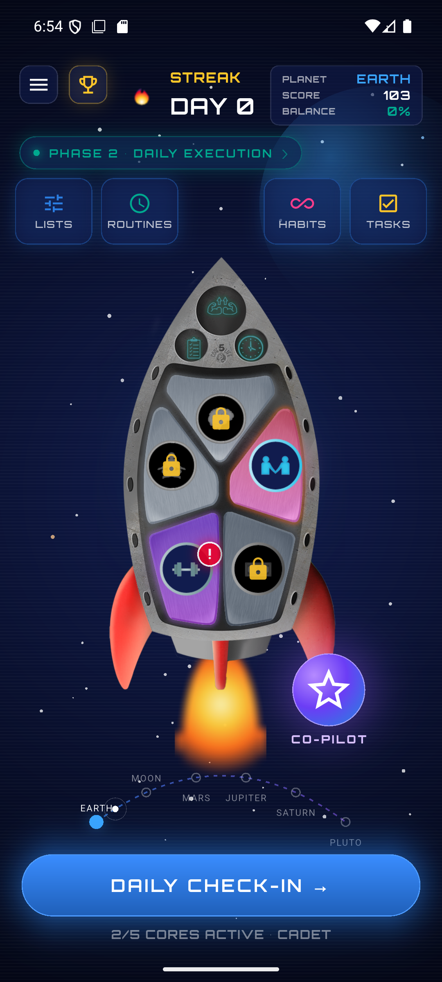 | 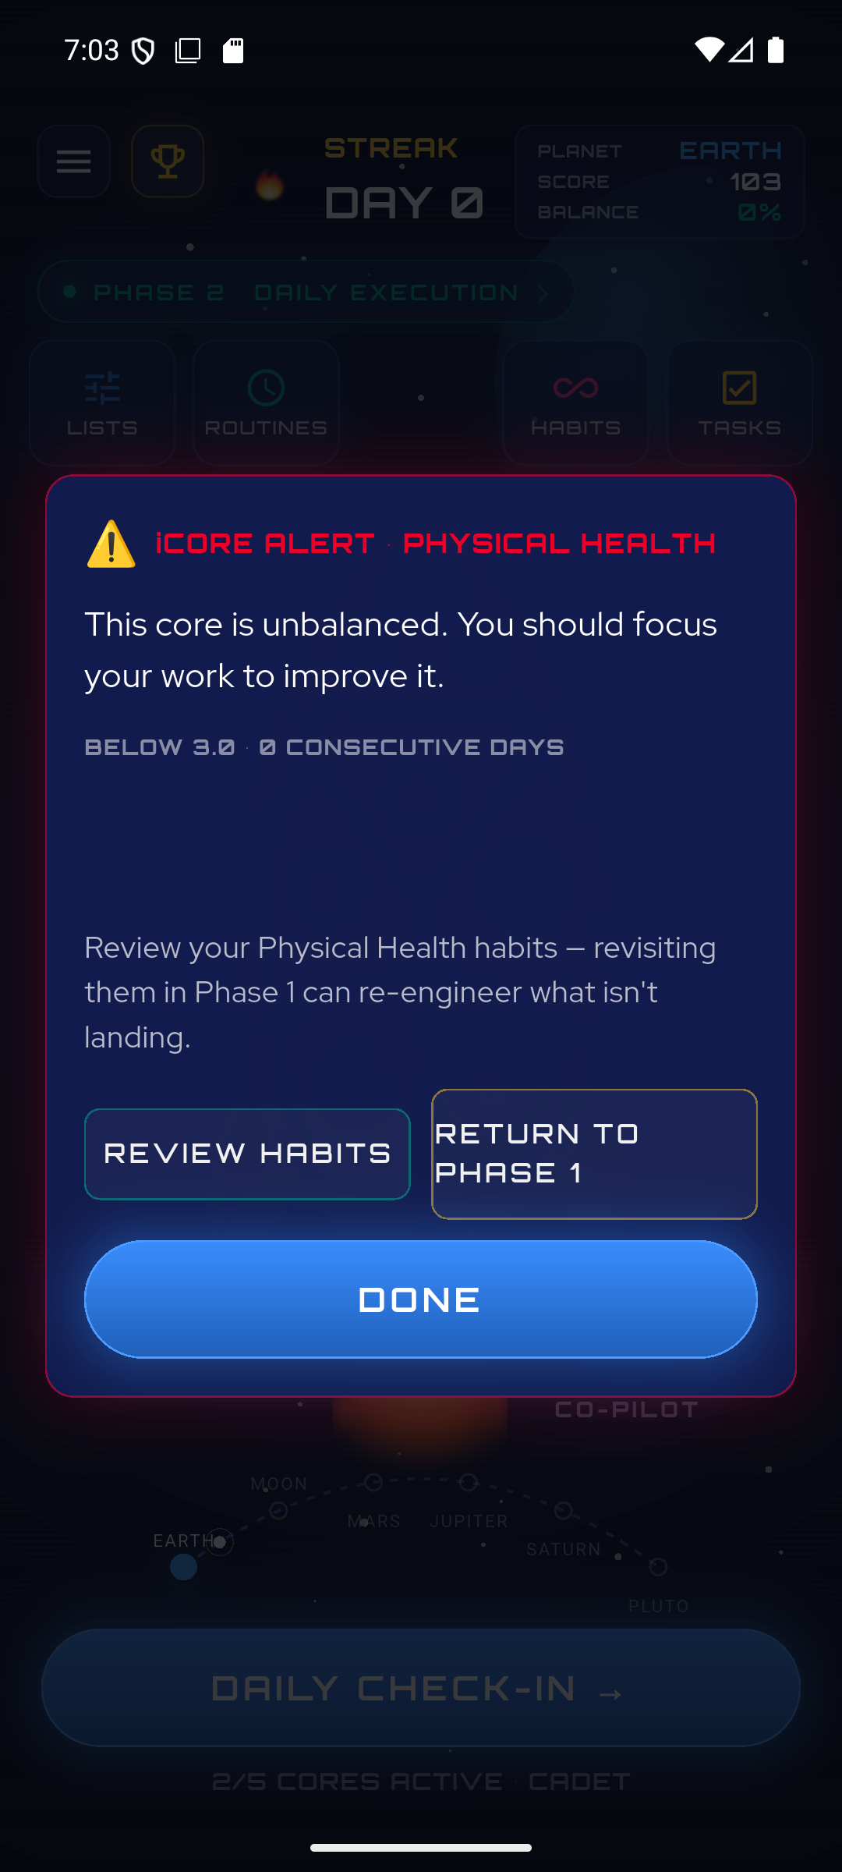 | 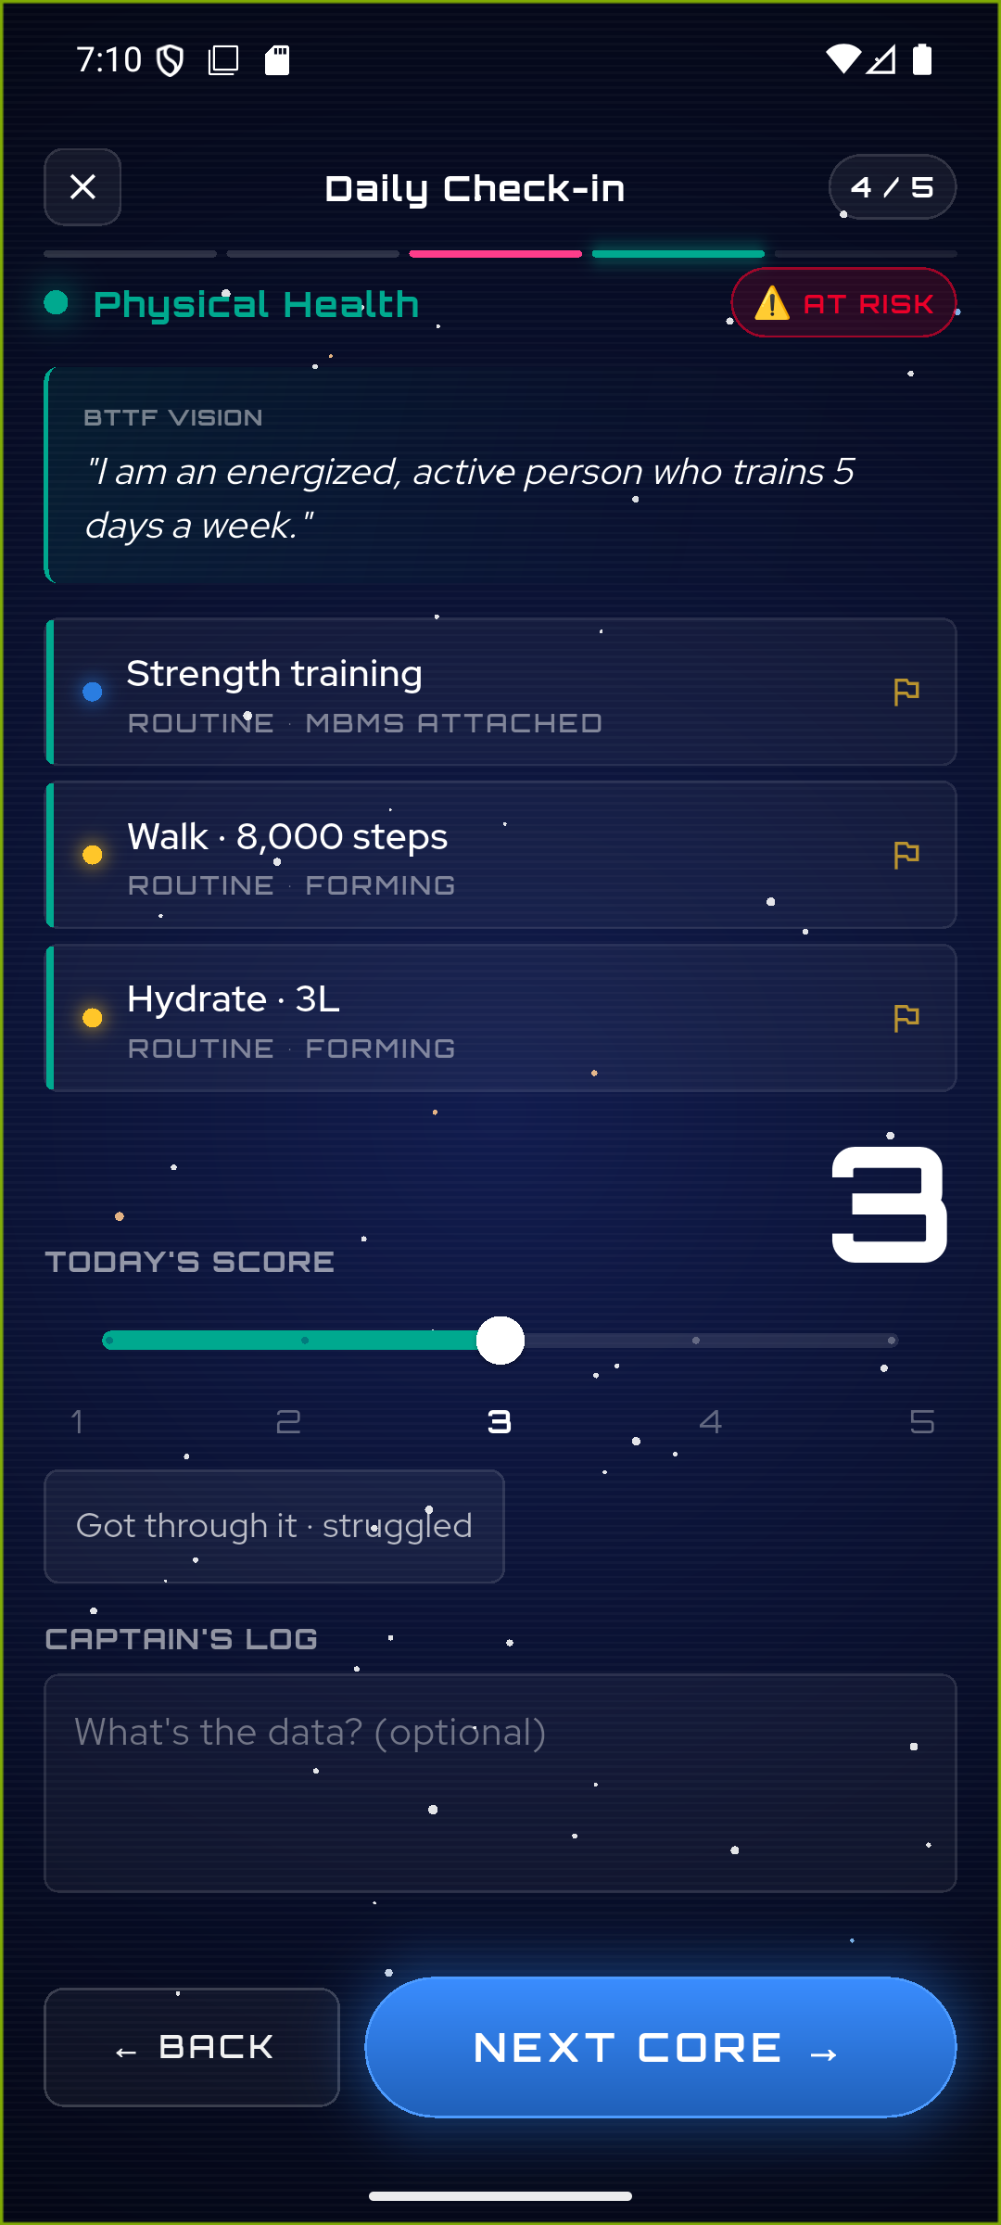
Left: the red badge on an out-of-balance Core on the rocket. Middle: the iCore Alert, with the exact wording from your spec. Right: the same alert reached from the “AT RISK” chip during the daily check-in.

M3 — Economy core

#9 Momentum Points engine
What this is: Completing a weekday check-in now awards +10 Momentum Points, saved to the player's running total with a per-check-in record, and shown as “Earned Today” on the recap.
Source — Document B (Gamification Mechanics Specs Reference) (extracted ref line 161):
“+10 points per completed weekday check-in regardless of scores — consistency matters most, not perfection.”
Built: New flutterAwardCheckinPoints endpoint awards +10 per completed weekday check-in, idempotent per day (re-opening the check-in won't double-award), written to the same points/summary + history + mirror schema as the Phase-1 awards. Weekends and empty check-ins award 0. The high-score (5/5), streak-milestone and Balance bonuses — marked [PLACEHOLDER] in your docs — are stubbed (the hook detects eligibility but awards 0 and flags “needs spec”) rather than inventing numbers.
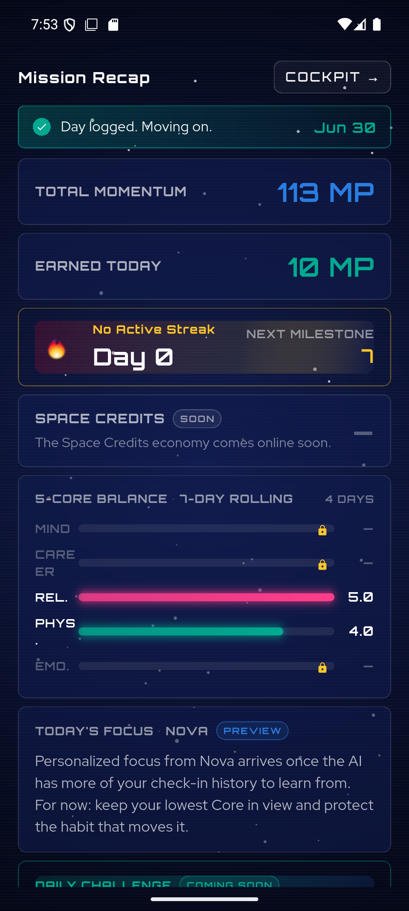
After a weekday check-in: Total Momentum rises 103 → 113 and “Earned Today” shows the real +10 MP.
Note on placeholders: Your Gamification doc intentionally leaves several amounts as [PLACEHOLDER — DETAIL NEEDED] (e.g. the high-score bonus, streak-milestone payouts, regression thresholds). Wherever a number wasn't specified, the code stubs the hook and surfaces “needs spec” instead of guessing — so nothing fabricated ever ships. These are ready to wire the moment you confirm the values.

#10 Streak system
What this is: A streak tracks consecutive WEEKDAY check-ins with a 4.0+ average. Weekends never break it, one missed weekday is a grace “warning”, and two missed weekdays reset it. Milestones (3/7/14/…/365) are detected.
Source — Document B (Gamification Mechanics Specs Reference), Section 6 "Streaks & Accountability" (extracted ref lines 335, 358-367):
“A streak requires consecutive WEEKDAYS (Monday–Friday) on which the player completes a check-in AND achieves a 4.0+ average score across all active Cores. Weekends … are always exempt … MISS 1 WEEKDAY CHECK-IN — Warning Only … Streak remains intact … MISS 2 CONSECUTIVE WEEKDAY CHECK-INS … Streak is broken … Always preserved: Space Credits, Trophy Room, … Level and all earned achievements.”
Built: The check-in award (flutterAwardCheckinPoints) updates the streak in the same step — weekend-exempt, a 1-weekday grace (“warning”), reset on 2+ missed weekdays — persisting streak / lastCheckinDate / longestStreak. The profile read reports the EFFECTIVE streak (ok / warning / broken) so the dashboard is truthful between check-ins. Milestones are detected; the reward amounts are [PLACEHOLDER] in your docs, so payouts are stubbed, not invented.
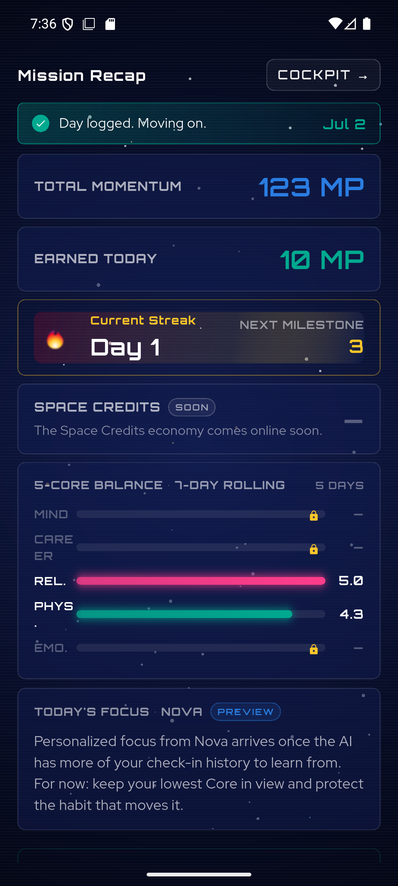
A qualifying weekday check-in starts the streak — “Current Streak · Day 1” with the next milestone at 3, alongside the real +10 Momentum Points.

#11 Trophy Room from real formation
What this is: The Trophy Room shows the player's real Golden Habits and whether each has formed — automatically after 14+ days of 80%+ consistency, or by manually marking it formed after a 2-week-standard confirmation. Habits still forming show a progress bar.
Source — Document B (Gamification Mechanics Specs Reference), Section 8 "Trophy Room & Habit Formation" (extracted ref lines 446-449):
“Formation Eligibility Threshold: 14+ days with 80%+ consistency (scoring 3 or above on the habit's Core on days the habit applies) … Early formation option: player can manually mark a habit formed earlier with a confirmation prompt acknowledging the 2+ week research-backed standard.”
Built: TrophyScreen was rewritten to pull real Golden Habits + the last 30 days of check-ins. Formed = the manual flag OR the auto rule (deriveRoutineStage == 'formed' — 14 days / ≥80% on the Core). Formed habits appear as trophies grouped by Core; still-forming habits show a {days}/14 progress bar and a “Mark as Formed” button → a 2-week-standard confirm dialog → a new flutterSetHabitFormed endpoint records formed + formedAt.
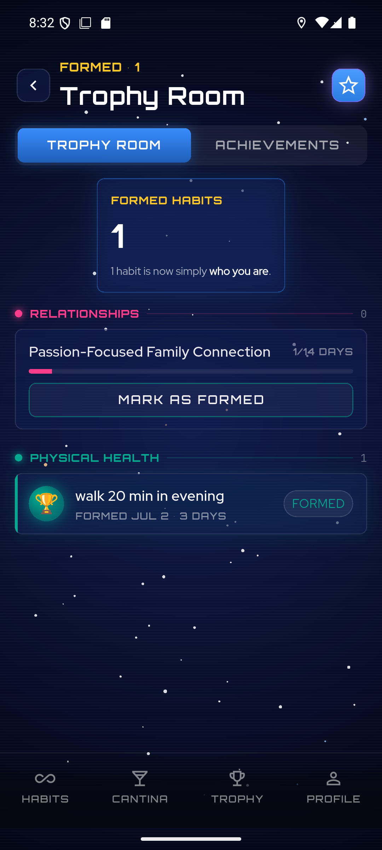
After marking one habit formed: “walk 20 min in evening” becomes a trophy (“FORMED JUL 2 · 3 DAYS”), the count rises to 1, and the other habit keeps its progress bar + “Mark as Formed” action.

M4 — Profile

#12 Profile screen real data
What this is: The Profile screen shows the player's real name, level, streak and Momentum score, plus a 5-Core radar computed from their actual check-in averages — no more placeholder “Alex Moore / 78-65-42-81-54”. Unwired settings are marked, and Sign Out works.
Source — Document B (Gamification Mechanics Specs Reference), Section 2 "Progressive Leveling System: Cadet → Navigator → Commander" (extracted ref line 107); the radar reuses the 5-Core Balance Meter (see #6).
“Progressive Leveling System: Cadet → Navigator → Commander” — the tiers carry [PLACEHOLDER] advancement thresholds, so the screen shows the player's current level as stored rather than inventing a level number.
Built: ProfileScreen now reads the real profile (flutterGetUserProfile) + the last 30 days of check-ins. The header shows the real name (avatar = first initial), level, streak and Momentum score; the 5-Core radar is the per-Core rolling 7-day average of check-in scores. Notifications / Connected calendars / Privacy / Subscription are tagged “SOON” (a tap shows a “coming soon” note); Sign out remains fully functional.
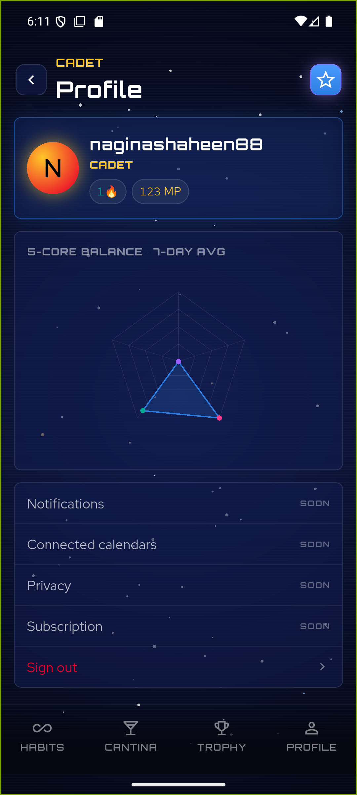
The real profile: “naginashaheen88 · CADET · 1 streak · 123 MP”, a live 5-Core radar from actual check-ins (Physical & Relationships extended, the rest centred), and the not-yet-wired settings clearly marked “SOON”.

3. Engineering notes (for your technical reviewer)
- Backend isolation: all new cloud functions live in the Flutter-only functions codebase (vf-bridge/functions-flutter), never in the FlutterFlow index.js. New endpoints this phase: flutterSavePhase1State, flutterSaveMomentumMethods, flutterFlagGoldenHabit (client wiring), flutterAwardCheckinPoints, plus read endpoints flutterGetUserProfile / flutterGetGoldenHabits / flutterSyncOnboarding.
- Points schema: users/{uid}/points/summary.total is the source of truth for momentumScore, mirrored to users/{uid}.points, with an immutable history sub-collection of awards.
- Verification: every feature was exercised on a real device/emulator and, where it touches the backend, confirmed against the live endpoints. Two effects need multi-day history to trigger live (the #7 auto-flag and #8 5-day alert); their UI and persistence are verified, and the day-counting logic is covered — they simply can't be clicked without several calendar days of data.

4. What's next
- The core product loop (#1–#12) is complete. What remains are two large DEFERRED buckets, both blocked on decisions/numbers from you:
- Gamified economy — Space Credits ledger, the Cadet → Navigator → Commander leveling thresholds, the planet journey + alien guides, ship upgrades, the Mystery Box, and the badge library. Nearly every threshold is marked [PLACEHOLDER — DETAIL NEEDED] in your Gamification doc.
- Full Space Cantina + Lists editing + Tasks — the social hub (MVP Reddit bridge → native Tribes / Ideas Well / Leaderboards), making Momentum Lists editable, and wiring the Tasks screen.

All screenshots were captured from the working app (physical Pixel 6 + Android emulator) during this build.

